Aim: Simulate cross correlation and autocorrelation on discrete time signals.
Program:
import numpy as np
import matplotlib.pyplot as plt
def cross_correlation(signal1, signal2):
# Compute the cross-correlation
cross_corr = np.correlate(signal1, signal2, mode='full')
return cross_corr
def autocorrelation(signal):
# Compute the autocorrelation
auto_corr = np.correlate(signal, signal, mode='full')
return auto_corr
# Define the discrete-time signals
signal1 = np.array([1, 2, 3, 4, 5])
signal2 = np.array([2, 4, 6, 8, 10])
# Compute the cross-correlation
cross_corr = cross_correlation(signal1, signal2)
# Compute the autocorrelation
auto_corr = autocorrelation(signal1)
# Plot the cross-correlation and autocorrelation signals
plt.figure(figsize=(10, 6))
plt.subplot(2, 1, 1)
plt.stem(cross_corr)
plt.title('Cross-correlation')
plt.xlabel('Time Lag')
plt.ylabel('Magnitude')
plt.subplot(2, 1, 2)
plt.stem(auto_corr)
plt.title('Autocorrelation')
plt.xlabel('Time Lag')
plt.ylabel('Magnitude')
plt.tight_layout()
plt.show()

Output:

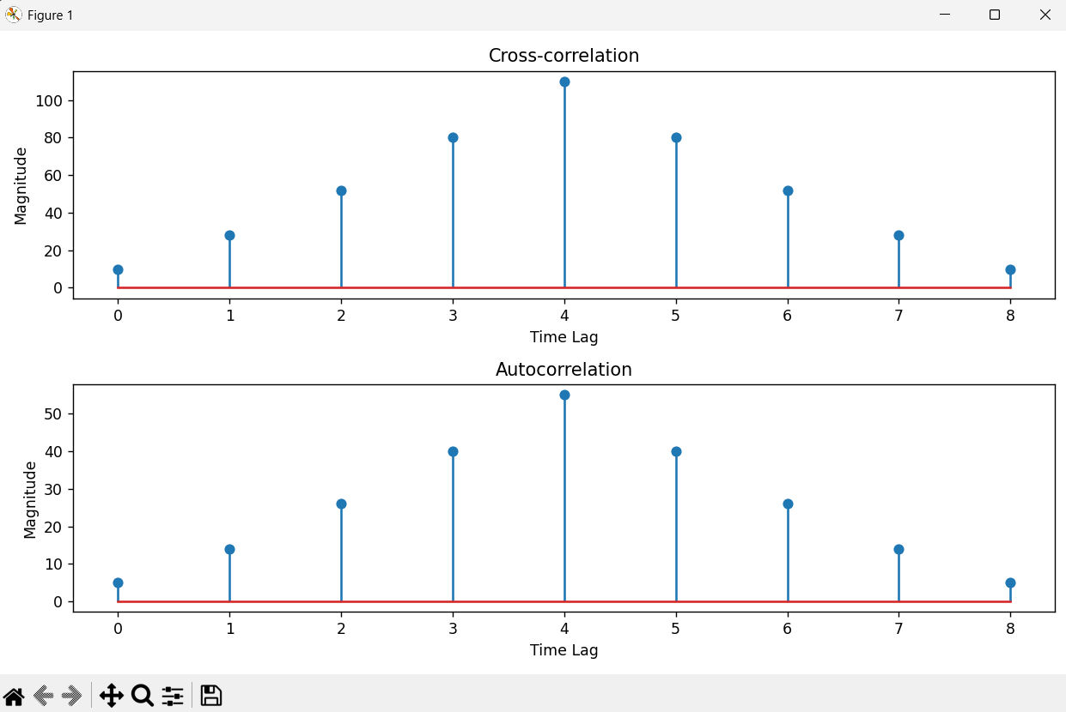
Conclusion:
The experiment successfully verified the properties of discrete-time correlation. Autocorrelation confirms maximum self-similarity at zero-time shift, while Cross-correlation accurately pinpoints the relative time delay and peak similarity between two different signals at lag 4. Both plots exhibit expected symmetry, demonstrating the practical application of correlation in signal detection and delay estimation.

